English version
~~SLIDESHOW~~
Multilingual Worshop MJC Duchère cultural association.
By: Gloria Reyes
MJC Duchère cultural center -
Grundtvig story savers project
and Projet Miriadi : Université Lumière Lyon2
Lyon- France
Public : All public. MJC Duchère members and Grundtvig storytelling European Project learners.
Number of groups: 1 (about 5-8 people) +
Partnership of Grundtvig about (20) “Story savers” .On 3th April 2014 .
Number of langues (2) : French work language for French workshops, English for the learners

Objective
General : To show the principles of intercomprehension in urban enviroment working in European projects at the same time: “Grundtvig Story savers” and “Miriadi” both are labed “lifelong education programme”.

Booklet
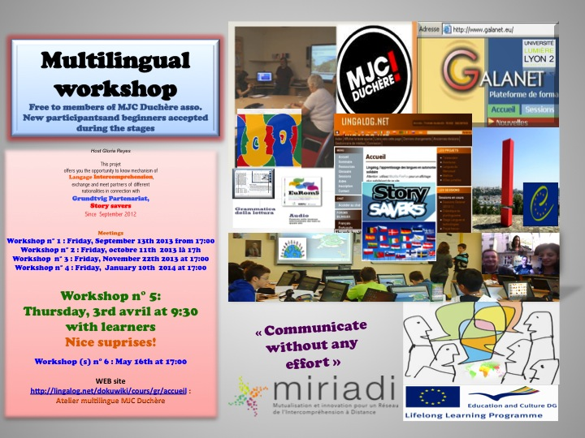

Linguistic objectives
- Brain-storming of linguistics.
- To discover family language trees
- To introduce the principes of intercomprehension (IC) for not specialists.
- To work in Roman languages and other groups of languages.
- To know in foreign languages :grettings, thanks, applications, based on project languages​​.
- Discussions about languages.

Key words
Grundtvig storytelling, partners, neighbourhood, district, langages discovering, family tree, mother tongue, Roman (latin) langages, langage(s) of project, story telling, linguistic and cultural preparation.

Session time
9 months in total: Session of two hours once a month or twice in each two months.

Description of the steps
0.Introducing : Proposition of work and public presentation at MJC cultural association (Openday journey).
1. Discovering languages. Family trees.
2. Linguistic and cultural preparation of next projet’s travellings : Ireland, Poland, France and Wales.
3. Intercomprehension in Roman languages.
4. Approach of langues and countries of the projet: Grece, Norway, Czech Republic, Poland, United Kingdown: national langages: Irish, and Gaelic.
5. Multilingual work with partners.
6. Possibility of connection, final teamwork participation of final activity of MJC Associationat the end of academic year.

Cultural
- To know cultural linguitics heritage of France. Not only French.
- Spoken langages in urban enviroment..
- Language identity.

Projet
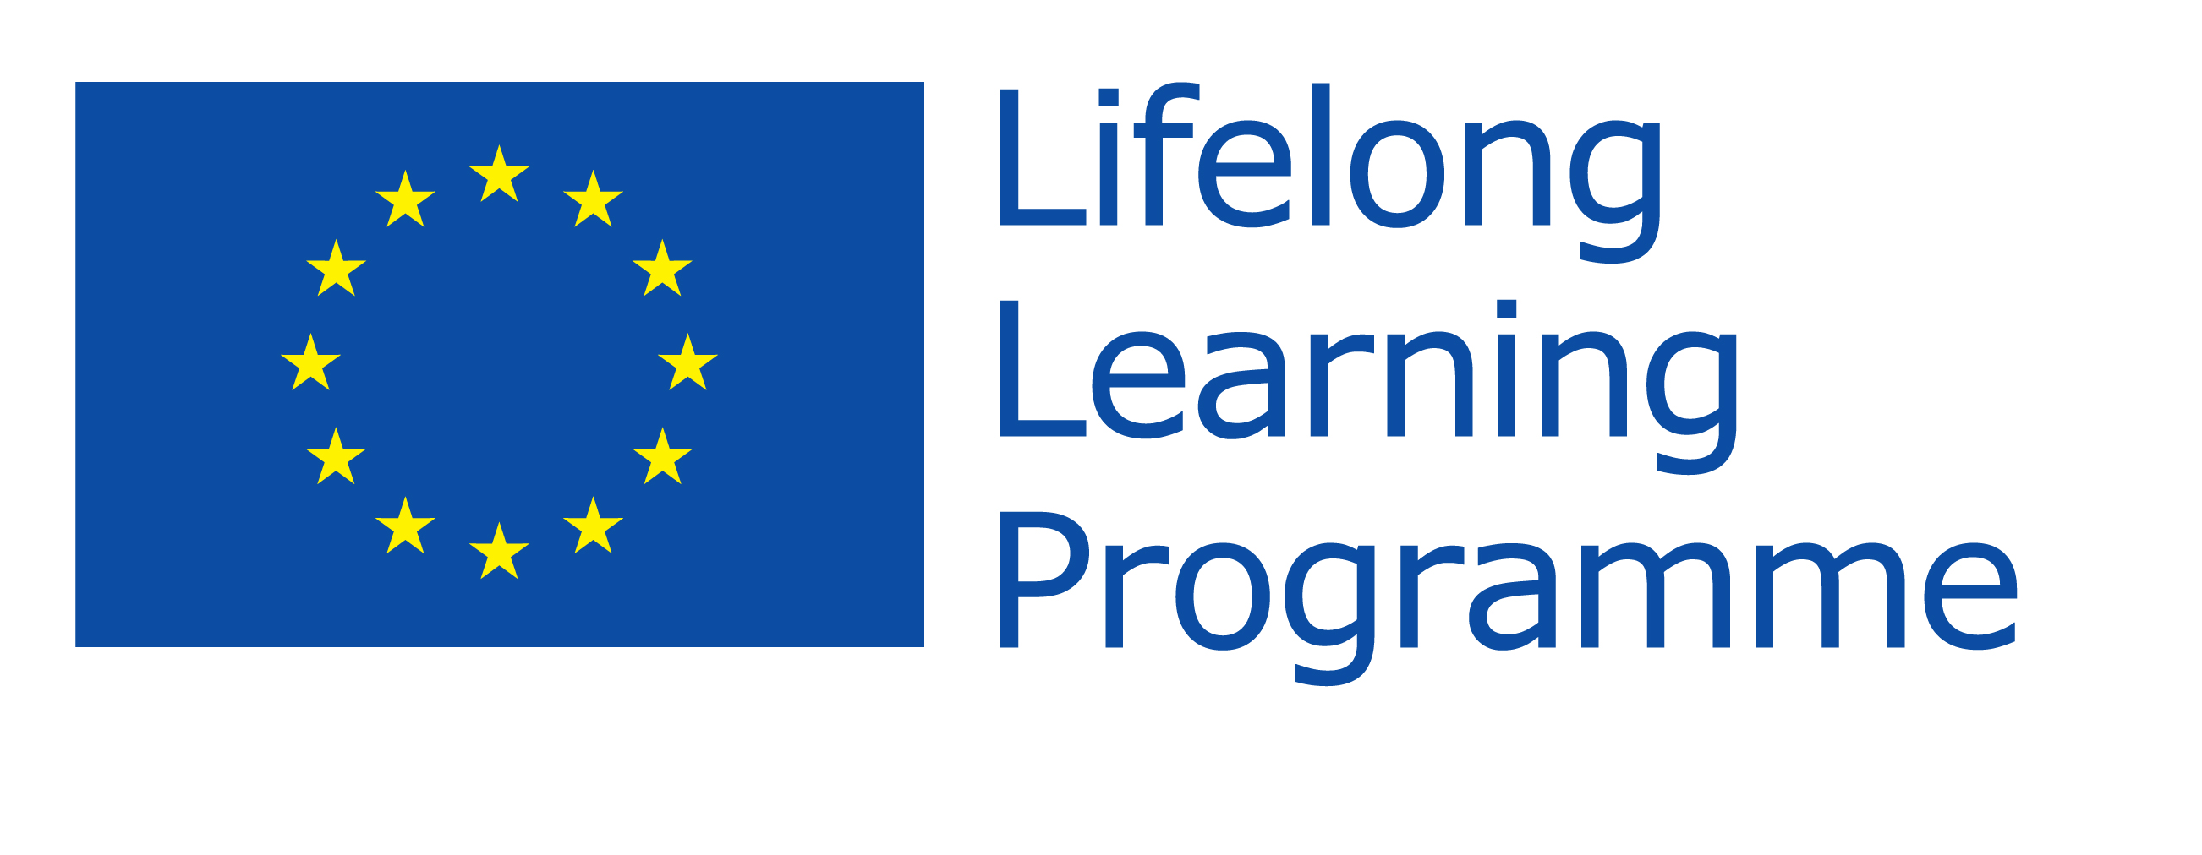
- Two projects in one worshop Grundtvig story savers et Miriadi.
- Linguistic preparation ( Kit to “survie”).
- Work in pairs - groups.
- Final project: On the web site or in common. Story savers blog.

Outils informatiques
- To work on lingalog's platform.
- Presentation of another tools: Eurom5, Dialogues en Intércomprehension, Itineraires Romanes, Galanet, APIC web site.
- Internet: you tube, etc.
- Connexion (if you were interested on Galanet's session).
- Participation quest.

Methodology
- Languages: langue, groupe des langues family .
- Activity work about the subject. Different sources.
- Discussion.
- Kit to “survie”: tools to recognise the language.
- Helping aids on the net: to work at home.
- Interview: Vidéo with a guest.

Dates
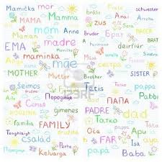
Workshop n° 1 | Friday, September 13th 2013 at 17:00
Workshop n° 2 | Friday,11th October 2013 at 17:00
Workshop n° 3 | Friday, 22nd november 2013 at 17:00
Workshop n° 4 | Friday, 10th January 2014 at 17:00
Workshop n° 5 | Thursday, 3rd April at 9:30 with learners
Workshop n° 6 | Friday, 16th May 2014 at 17:00

Introduction
What's IC? : ⇒ Intercompréhension
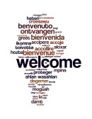
Ancien projets
⇒ Galanet
⇒ Groupe
⇒Session

13th September 2013
~~SLIDESHOW~~

First session
Objectives
- To discover languages without studying.
- To introduce: Lingalog, Galanet, Miriadi ..
- Découvrir les familles des langues: Le Pain
- Proposition de participer dans une la séance de Galanet session A premier semestre. travail à distance.
- Travail pratique: Inscription sur les forums bilingues. Participation. Chat.
- Kit Irlande: Practic tools.

- 1. Profil langagier
Nous allons parler des langues que nous connaissons dans l'atelier .
Dans quelques semaines temps un questionnaire en ligne vous sera envoyé.
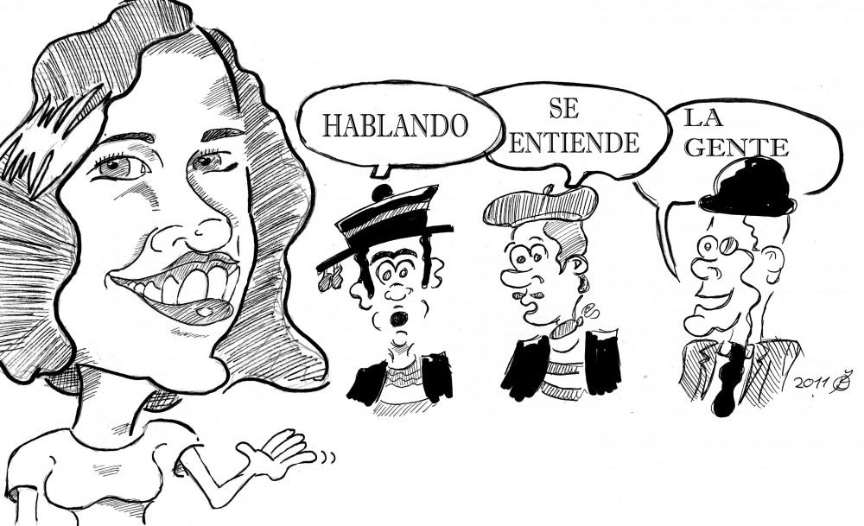
⇒ Profil langagier

- 2. Family of languages
* On line about “bread”: ⇒Pain * Discussion.

- 3. Kit to "survie" : Ireland
A survival kit to languages Grundtvig storytelling to go to Ireland. Even if you don't travel.
Voir: Irlandais
- What do you know about Ireland?
- Photos: Do you recognise this language?
ireland_photos.docx | 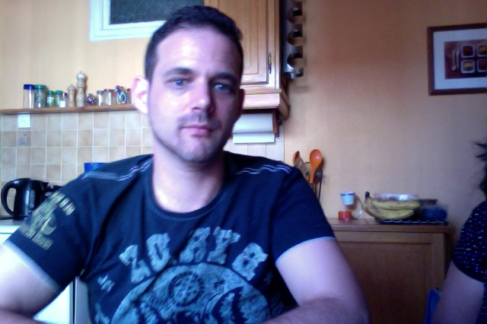 | english_word.docx
- Documents: Irish or French?
|
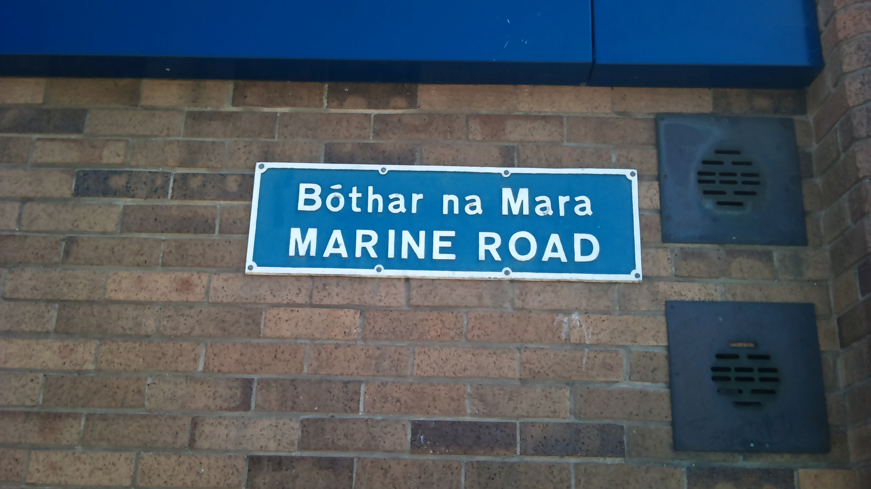{{:cours:gr:dsc_2506.jpg?300|
- Video: Oral Interview with Luke an Irish -French. Bilingual Conversation Spanish - English
- About Ireland and the National language. ⇒Irish

4. Conclusions
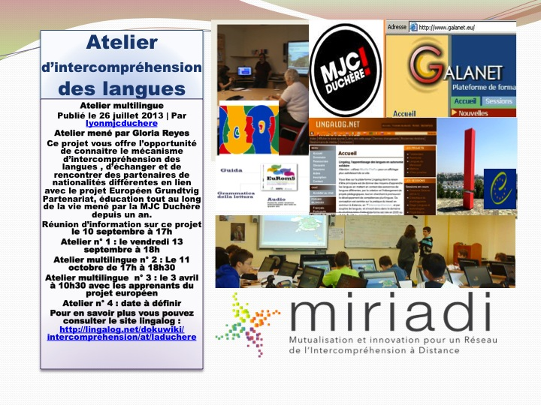

11 October April 2014
Workshop 2: To discover Roman languages
Introduction
What about Roman languages? a web site ⇒Etnologue romance
Some articles/pages/links in English :
http://www.english.illinois.edu/-people-/faculty/debaron/584/584reading/costa%20lambert%20frenchlangpol.pdf
http://www.merriam-webster.com/dictionary/patois
Activity Vozes
⇒ Atelier “Vozes” Multilingual vidéo, to discover languages
Activity APIC With this workshop we will explore the reading strategies in Romance languages. We will be able to read in languages ​​that we never studied
Thanks for Pierre Janin a former Special Adviser to the General Delegation for the French Language and the Languages ​​of France .. and now an active member of the APIC (Association for the Promotion of Intercomprehension languages​​) Through press texts, short and authentic, Catalan, Spanish, Italian, Occitan, Portuguese, Romanian.
Surprise you get into these texts and understand the meaning, then you have never done these languages. The mutual understanding is a key modest but very quickly effective entry into an active multilingualism.
Web site ⇒APIC http://apic-langues.eu/
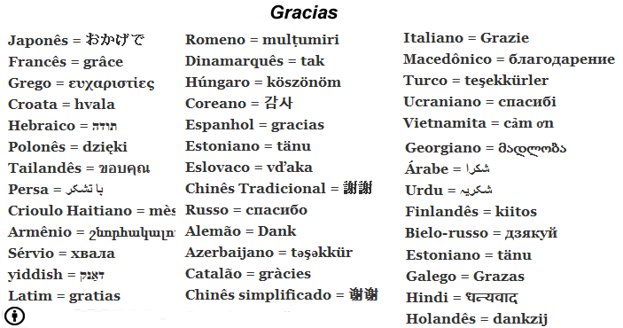

22 November 2013
Principles of mutual understanding
From: APIC - Training in November 2013
1. Aim for Intercomprehension 2. Proximity / relativity 3. simultaneity 4. immersion 5. Central focus of the L1.
strategies
1. Context. 2. Using the audio 3. Principle of magnifying glass 4. Games similarities in the languages 5. Take support on intuition 6. Readjustments after cutting.
work:
Reading texts. Multilingual make history. Set to “survival”: PolandLearn about computers. How lingalog work?
Set to “survival” Polish
links: Polonais

10h Janvier 2013
- Kit to “survie”: Survival kit : How do you say “good moning in project languages?
GR Grec NO Norvégien TCZ Tcheque
* Introducing Creole. Créoles de base lexicale française Listen in different creoles a tale: “Le pays d'en bas la mer” http://www.collectif-haiti.fr/data/file/Newsletter/Le%20pays%20d%27en%20bas%20la%20mer%20texte%20original.pdf
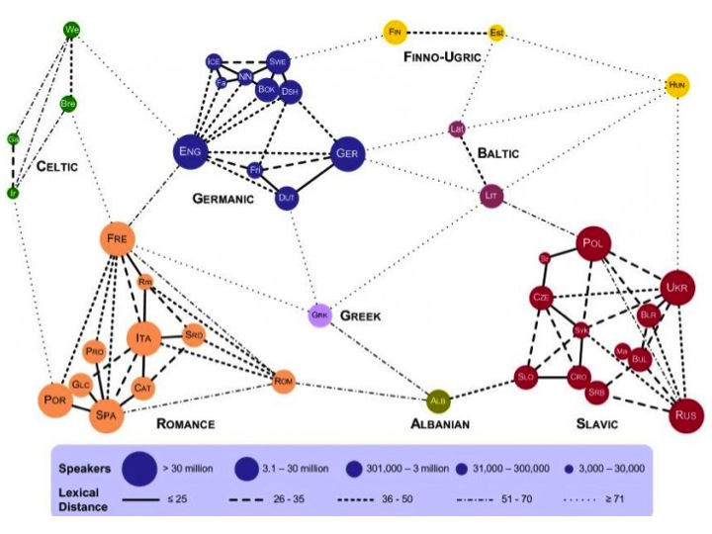
Families of languages Web site: http://techtastico.com/post/distancia-lexica-entre-los-idiomas-europeos/
Resources (French) ⇒Sites multilingues pour apprendre les langues

3rd April 2014
- Welcome to France
- Meeting ith partners from: Meeting with partners
- “Welcome to France” : Greece, Norway, the Czech Republic, Poland, Wales, Ireland.
- Linguistic exchanges
- Groupe games
- Knowledge about France “Survival kit”
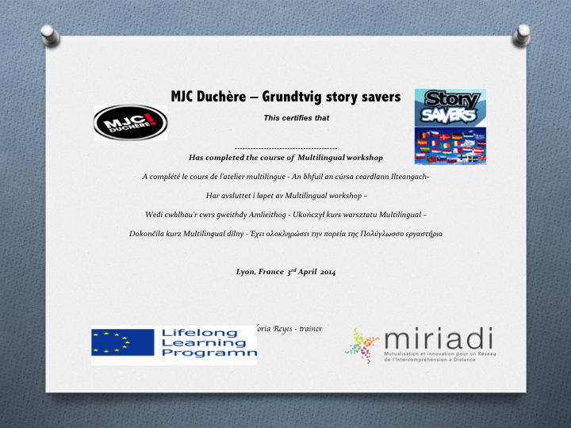
Programme: english_presentation-1.pdf Diploma

16th May 2014
Next trip Wales September 2014. Final destination
Conclusion. Final Project.

Links
⇒ Click on
☛ Blog Story savers
☛ Site Internet MJC Duchère Ateliers Multilingues

